**Pet Health Monitoring Through Movement**

Contents

Analysis 2

The problem 2

Stakeholders 2

Clients 2

Vets 3

Research 3

Primary – Interviews 3

Primary – survey 4

Secondary – competitors 7

Solution 7

Aims 7

Objectives 7

Prototyping 9

Appendix 11

Analysis 11

# Analysis

## The problem

Many recent owners of pets acquired them in lockdown[1] when they were always home and able to spend a lot more time with their pets. However, with working places shifting back to requiring work in offices[2] owners will have less time to spend with their newly owned pets due to commutes. This can lead to problems of pet’s having less attention from the owner and the owner becoming less used to their behaviour. This can cause for a rushed visit to the vets if normal pet behaviour seems strange to the owner. Which can cause large costs to the owner and wastes the vets time when they could be seeing a pet which is in actual danger.

In fact, due to the covid pet boom there are more pets than vets can handle causing many professionals to leave the field. With large numbers of vets leaving the system[3] only exasperating the problems. Therefore, it is necessary for there to be an alternative way to provide a helping hand to the owner with taking care of their pets. This would not only reduce the strain on the current system but also help owners with reducing the high costs involved in veterinary care while helping the pet live a better life.

In fact, consumer spending is also increasing with pet care expected to increase from $250 billion this year to $370 billion by 2030[4]. Some of the main drivers from this increase in increased consumer spending on advanced pet care products. However, one of the expected slow downs is due to higher costs as it will “limit their demand among lower-income population” [5].

Therefore, I am designing a product to be a helping hand to owners and vets allowing for earlier discovery of problems while providing the vet with valuable accurate information on the pets living arrangements. This should all then be reasonable priced to enable maximum reach.

## Stakeholders

### Clients

The client for this project would be any pet owner. This could range from busy commuters who are unable to spend time with their pet to owners who are paranoid about their pet’s health. It should also be used to help save money as regular vet visits[6] generally aren’t covered by insurance. I should also make ease of use as one of the key criteria to allow for owners properly using the features of the product. Furthermore, as I am also aiming for pet owners to save on medical bills it should be as cheap as possible. First construction costs will have to be higher because I won’t be making custom PCB components for circuit boards, and instead using Raspberry Pis. However, I will set a budget based on my end user’s request and try to keep to this throughout the project.

### Vets

Vets are a major stakeholder to this project as the project will not be able to replace a proper diagnosis but, instead a tool they can use to detect issues more efficiently. This is because it will provide valuable information to changes in routines. Therefore, this product must have tools which can be easily accessed by the client to share information to the vet. There should also be a way to enter this behaviour into the algorithm post diagnosis so the product can provide valuable insight to other users.

## Research

### Primary – Interviews

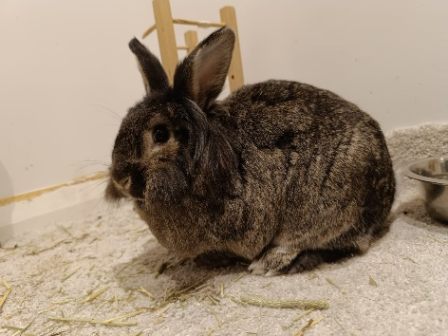

Cinny – A lionhead mix rabbit.

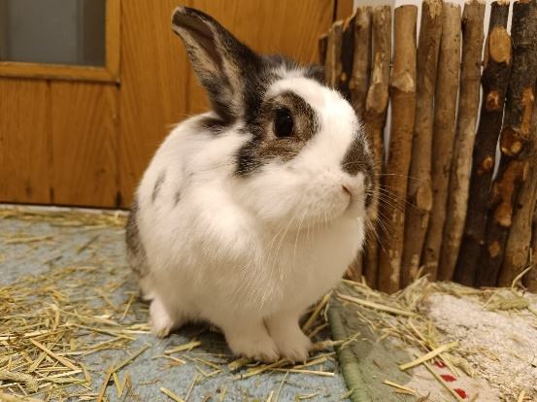

Cleo – lionhead mix rabbit – recently undergone eye surgery – blind in one eye

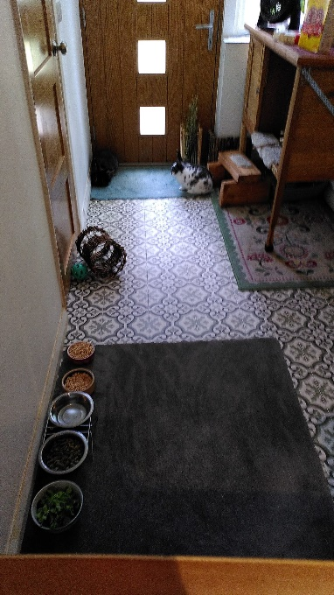

The room which is inhabited by the bunnies

#### End user

The first interview I conducted for this product was with my intended end user Michael Scholand. I chose Mike as I have easy access to his animals (two twin girl rabbits, both spayed) and I can therefore quickly change out hardware if there are problems. He also has time and is willing to interact with the project when is necessary, and he is quite proficient with a computer. I will summarise the findings of the interview with the rest being contained below[7]:  
The client has two rabbits for over 3 years, both of which are sisters and lionheads, both rabbits have been infected with E. coli from their litter. This has impacted one of the rabbits by developing a cataract and needing to undergo surgery. With the other rabbit there have been no visible signs of sickness from E. coli but has been proven to have it through blood tests. Mike has had lots of experience of taking care of a variety of animals in his past. They are contained within a sizable room allowing for exercise. He doesn’t have insurance and therefore his average checkup cost is around £100. On a previous occasion he has rushed Cinny to the vets when after returning from a trip he spotted abnormal behaviour. This took around 3 hours of his time and cost £250-300, although he was still happy to bear this expensive and was impressed with the level of care, he could get at 11pm on a Sunday night he admits that it was quite costly for him. He is also concerned when he leaves for trips about the bunny’s health as he is unable to intervene in a situation concerning their health when he is away. This means my product should have levels to indicate if there is a decrease in health, so my client is able to plan accordingly before leaving for trips. Finally, he has indicated that he would be willing to spend around £100-150 for a solution which would help to give him peace of mind/warnings about his two pets health.

#### Subject expert

To gather further information and the feasibility of this project. I interviewed Rachel Barnes a vet working at East Barnet Veterinary Surgery, she is also the main vet for Cinny and Cleo. I will summarise the important parts of the interview here with the full script below[8]:

Rachel first confirmed that the premise of assessing health of a rabbit through movement is feasible as: “Definitely because rabbits are a prey species … if they show illness, they would think they would be picked off by a predator … if rabbits are in pain, they are less active and less mobile”. Therefore, just by assessing movement patterns we should be able to assess a change in condition. However, diagnosing a condition though movement alone would be more difficult as there are many other signs which need to be notices – for example the grimace scale[9]. Therefore, I need to build a model which is sensitive enough to notice changes in behaviour but not too sensitive to be triggered by everyday behaviour. Rachel also highlighted how it could be useful in home care to be able to identify when pets are recovering as there would be an increase in movement and energy. One of her main points was that the product would be very interesting on geriatric cats as there is a type of arthritis which is easily curable with new medication. However, most owners are unable to pick up on this change of behaviour due to assuming that its just aging of the animal. Unfortunately, I don’t have easy access to any cats and working with a gps collar would be more difficult for me. To not block off future opportunities in expanding my product I will priorities encapsulating, where possible, the analysis part of my product to allow for different methods of capturing movement.

### Primary – survey

To gather more information from a wider range of people I sent out a survey asking similar questions to my interview. Allowing me to gauge interest for such a product and to work out what are some of the main reasons owners take pets to emergency vet trips.

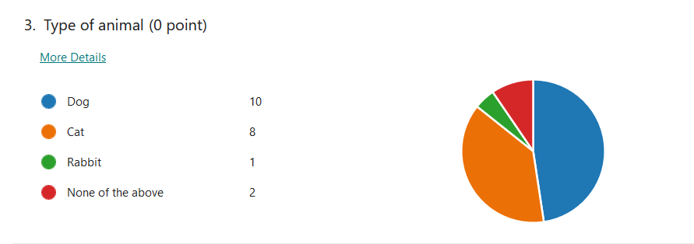

The vast majority of responses come from cats and dog owners which is to be expected as even the third most popular pet in the UK is considered exotic[10]. The only 3 non cat/dog entries where from a rabbit owner, a hedgehog owner, and a gerbil owner.

Many owners visit the vet yearly or whenever the animal is acting strange. This shows how owners are concerned for their pets.

Many owners have rushed their pets to the vets just to find out their animals was fine. But to also see that this is only by a slim majority shows how often pet owners are correct are identifying strange behaviour. This shows that having a device to reassure owners would be helpful, as it should decrease false emergency visits.

The number of people who responded to the survey who had insurance is surprising as the national average is closer to 18%[11]. This shows how my survey is more likely to have been responded to by owners who are very concerned with their pets’ livelihoods. This can also explain why so many of the responders take their animals to the vets whenever they are acting strange.

What is surprising from this chart is how much people spend when visiting the vets. As average standard vet visits generally cost around £50[12]. With 6 responders paying above £100 per visit shows alongside the insurance rate just how much they care for their pets.

Many responders also indicated interest in my product showing that there is demand for such a product. This may also be due to owners not knowing about existing products due to lack of advertisements. I will look further into such product in the next section.

In summary, my data may have been skewed by more caring pet owners than average. It would be expected that these owners would be more interest in such products as mine. But as over 75% of owners are still interested, it shows that there is a large interest for such products. Most of this demand will be concentrated into cat and dog owners. Therefore, I must make this product adaptable in the future toward other animals by separating the analysis from the data collection.

### Secondary – competitors

There are several different companies in the smart sensors for pets’ business, but none are target towards animals other than cats and dogs. This might be because all the companies I found only had collar methods for gathering this data. This wouldn’t work for many smaller animals as they weight of the collar would be a greater percentage of their body weight. Another reason seems to be because their main targets are for the larger market of dogs and cats. And as they are larger animals a larger area of coverage which isn’t possible with non-intrusive methods like cameras. This requires them to use batteries which must be easily chargeable and sensors which must be always on the animals. Therefore, I will investigate these products and see what makes them attractive to pet owners and try to replicate universal features where possible.

#### Product 1: Tractive GPS Cat Tracker

This company has design multiple collars, two for dogs and one for cats. The product I will be looking at is their one for cats[13]: It costs £45 pounds alongside a subscription with two tiers – basic and premium. For the shortest amount of time cost of basic package is £12 per month whereas for premium is £7 per month where they lock you into payments for a longer time. It is designed to be worn around the cats’ neck and provides location data to the user alongside a wellness score showing the cats habits. It requires recharging every 48 hours and an app to be able to interact with any information. One of the interesting tools it gives the user is a virtual fence whereby it sends alerts to the user when the cat has left a set zone. Risks with this product - if the company ever closes you will lose all functionality to the collar as it depends on the subscription and app. Furthermore, a 48-hour life span requires the pet owner to recharge the collar quite often. Also, there is little to no self-repairability due to the waterproof casket[14] so you are completely dependent on the company for repairs.

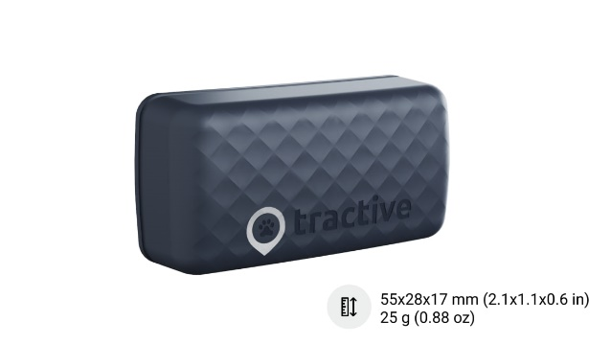

Image of the tracker. Credits Tractive website

#### Product 2 Maven Collar:

This company only has one sensor for both dogs and cats[15]. Costs are: $99 for initial collar and $29 per month for their silver plan or $79 a month for their gold plan which they claim is their most popular plan. It doesn’t have a GPS tracker but instead provides more accurate health assessments through use of an AI system. The reason for their high subscription cost is because they offer on demand vet chat or video lines and with their gold plan also offer custom diets alongside weekly check-ins by a vet. However, it doesn’t offer insurance so when it comes time to visit the vet in person the trips will still cost you. One of the interesting features is the medication reminders and logs, this reminds the owner when they should be providing medicine to their pets. Furthermore, the information they give to their online vets allow them to make accurate assessments on problems with the animal. I couldn’t find battery life on their website, but it is claimed to be 4-6 weeks[16] elsewhere. Risks and problems with the product – they only have an IOS app which locks all the gathered information. I was also unable to find any self-repairability so you are dependent on the company and may need to buy new collars if your current one breaks.

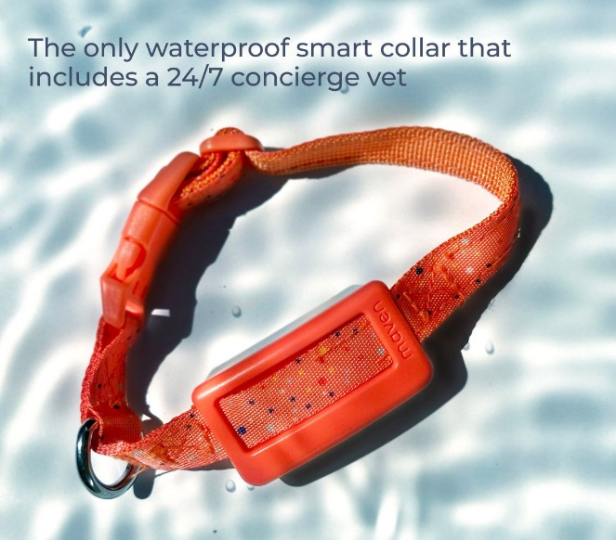

Image of the tracker. Credits Maven website

#### Product 3 FitBark 2:

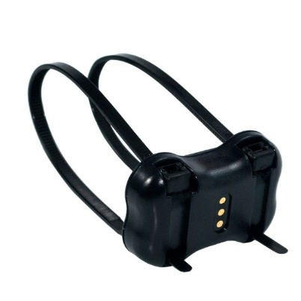

Image of the tracker. Credits FitBark website

This company offer two types of health measuring devices one with GPS the other without. For this I will be reviewing the one without[17] due to the GPS device being only available in the US. It has a one-time fee of $79.95 to get the collar attachment. Monitors their health through movement, quality of sleep and activity counts. The battery lasts up to 6 months. Offers comparisons of your pet to other pets. Has a developer API meaning that the app isn’t necessary. However, doesn’t offer repairability so if it breaks you are forced to buy a new one.

### Conclusions

There is demand and interest for health-related pet products. However, most are tailored towards cats and dogs leaving a large market open for other pets. Furthermore, I could not find any non-collar solutions which would be necessary for rabbits. Important features I’ve found is an alert system for when a pet leaves the range, long battery life, and easy of delivery of information to vets.

## Solution

I will be making a non-intrusive system through use of cameras. As the rabbits stay in one room most of the time if I have coverage in that room, I can run an object detection algorithm to locate where each rabbit is. Then I can use pixel distance between different measurements from object detection I can calculate distance moved. I will attempt to gather this data by the second to get the most amount of accuracy. This data will be collected into a database where a model of average daily/hourly behaviour will be made. When enough data is collected ~ a week – it will begin to check for outliers. If a datapoint is outside a certain range this will be reported back to the user. The user can then look at the data and check on their pets to see if something is wrong. If there is a problem, then the user can print off charts of their rabbit’s behaviour and take that alongside their pet to the vet. The vet should then be able to take a diagnosis of the behaviour and suggest to the user what steps they should take next.

### Aims

|  |  |
| --- | --- |
| Primary aims | Secondary aims |
| 1. Have a non-intrusive camera system which won’t impede the rabbits. 2. Collect data and build into a model. 3. Use the model to assess new data and replace old data to create a rolling average. 4. If data is anomalous report strange behaviour to owner. | 1. Have a convenient way to summarise behaviour in past and present which can be shown to the vets. 2. Separate data from analysis to allow for data from different sources. 3. Make affordable so don’t use high-cost components. |

### Objectives

|  |  |  |  |
| --- | --- | --- | --- |
| Group: | Summary | Primary objective | Secondary objective |
| 1)Data collection | As the animals I am assessing are rabbits they move shorter distances and won’t wear collars therefore I will make use of a camera system. The size of the room the rabbits are contained in is too large for one camera so I must use a multi pi system | 1. Set up raspberry pis. 2. Add cameras to the pis. 3. Start networking the pis together using ethernet and a switch. 4. Take photos at regular intervals. 5. Send the photos to the server | 1. Confirm server can receive files before sending. 2. Add a queue to store files waiting to send. 3. Add a database for images yet to send so no data is lost if power goes out. 4. Synchronise the pis to take photos at the same time. |
| 2)Raw data processing | After the images are sent to the server, they need to be joined so we end up with one large image. | 1. Stitching algorithm to join the images. 2. Add multiprocessing to avoid impacting the rest of the program | 1. Set up a networking receive and echo the file names back when ready to send. 2. Cache results to speed up image stitching. |
| 3)Object detection | This new larger image needs to be analysed by the object detection software before being moved into storage. | 1. Use a prebuilt object detection algorithm for rabbits. 2. Decide level of difference of pixel movement to classify as movement. | 1. Train my own model    1. Pick a transformer to use.    2. Pick a model which will maximise speed without too much loss to accuracy.    3. Make training data.    4. Train the algorithm for the specific data.    5. Implement to run in real time. 2. Detect humans on top of rabbits to measure prey response. 3. Set up to at times of lower movement run fewer checks. Back track if movement is detected. |
| 4)Storage | There needs to be a method to be able to note down and contain all the data which the cameras gather. We cannot also store all the raw images as there is a storage constraint of around a terabyte | 1. Use SQLite database to categorise the images and store the values of rabbit locations. | 1. Make a MySQL database. 2. Store images in grey scale. 3. Remove older images to save storage. 4. Make a table for each pet under an owner table. 5. Add a 3-day local backup on Pis. 6. Add a SQL category for detected humans to allow for a burglary expansion |
| 5)Analysis | We need a way to be able to give reports as to how the rabbits are doing. | 1. Track amount of time spent moving per day. 2. Track distance moved in a day. 3. Record the tracked values for each day. 4. Add this tracked data to another table | 1. Try to track time spent eating. 2. Try to track time spent in potty. 3. Track prey response so how rabbits react to human. 4. Calculate if recorded values have anomalies. 5. Make a standard rolling model where each new day is compared to only the last two months in data. 6. Allow for data of any format so later can be upgraded to a GPS system. 7. Use automata to give different levels of warning for the rabbits. 8. Check rabbits are in frame, otherwise send warning. |
| 6)Display | The user needs to have an easy way to see reports on how the bunnies are everyday | 1. Set up a front page where you can select which rabbit you want to see information on. 2. Page on each of the rabbits showing what is found in analysis. 3. Printing report page for vets. | 1. Build a login page. 2. Have a heatmap for each rabbit showing their most common areas. 3. Show a path of where the rabbit went around for the day. 4. Add a daily gif going through the entire day to the front page. 5. Add a scatter plot showing todays behaviour compared to total history. 6. Add a page to customise your front page – eg add images for each rabbit 7. Report production on your rabbit for the last month. |
| 7)Testing | Due to limitations and being humane I will not be infecting my rabbits with a disease to prove the product works. Instead, dummy data will be used to show how to product will respond when one rabbit is not active for an entire day. |  | 1. Create dummy data. 2. Test if data is lost if server suddenly goes down. |

## Prototyping

To test whether this idea would be possible I build a camera rig to test if we could use multiple cameras to cover the 2x4m room because one camera doesn’t have a large enough FOV. I then had some assistance from my end user when dealing with the wood saw and installation into the ceiling.

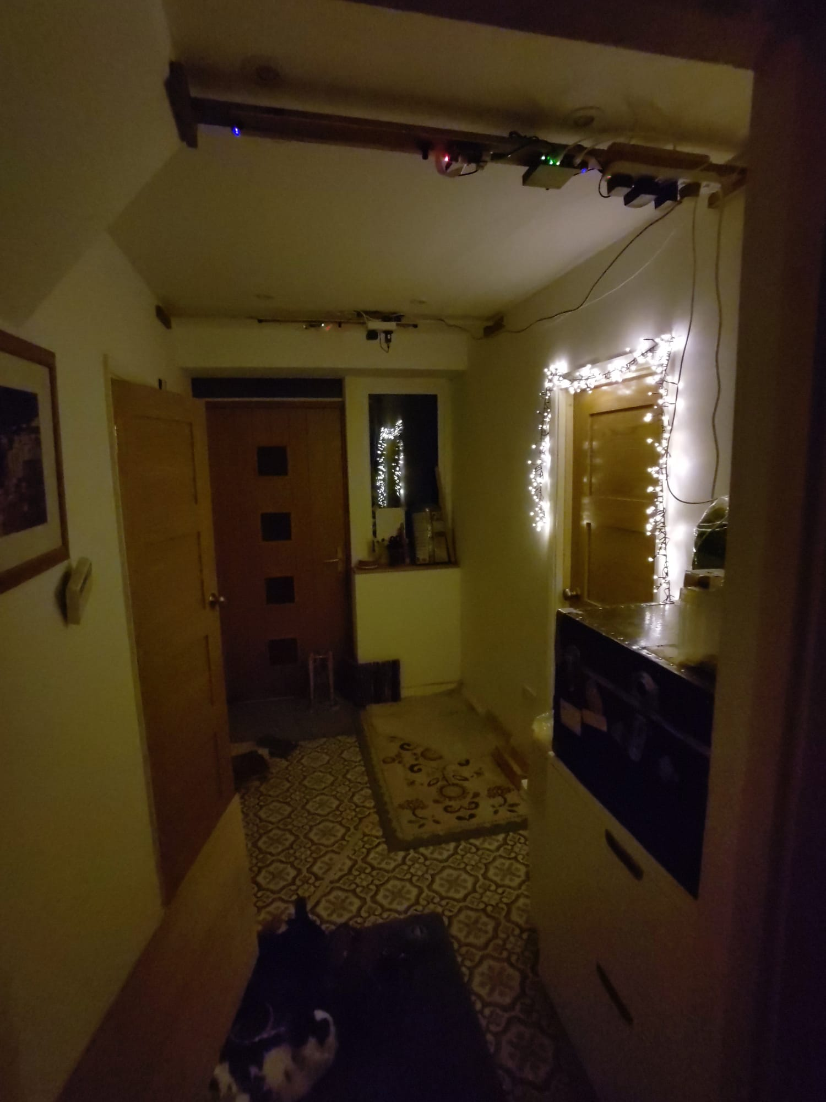

Full shot of room Raspberry Pi Camera Board - Night Vision & Adjustable-Focus Lens (5MP) installed.

From this image you can see how we built this prototype. Two raspberry pis strung across the ceiling divided across the room. Our first attempt involved using the “Raspberry Pi Camera Board - Night Vision & Adjustable-Focus Lens (5MP)”[18] made by waveshare. However, there were several problems with these cameras. First, they lied about their FOV being 70° when it was only 50°. They do not contain an infrared filter which is both a positive and a negative. It allows it to take images in the dark however when images are taken in full light, they are very pinkish. See below.

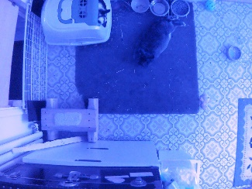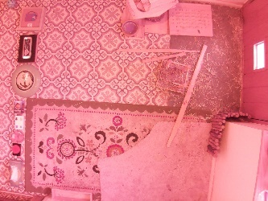

Day image of Raspberry Pi Camera Board - Night Vision & Adjustable-Focus Lens (5MP)”

Night image of Raspberry Pi Camera Board - Night Vision & Adjustable-Focus Lens (5MP)”

Furthermore, when using my image stitching algorithm[19] even after putting objects in the middles there weren’t enough points to make a match due to lens warp in the edges. This is because the confidence minimum to be able to stitch two images together is 1 whilst the image was only achieving 0.04.

Therefore, we decided to upgrade to the “5MP Motorised IR-CUT OV5647 Camera for Raspberry Pi”[20] This had a horizontal FOV of 85° which is enough to have a sizable overlap.

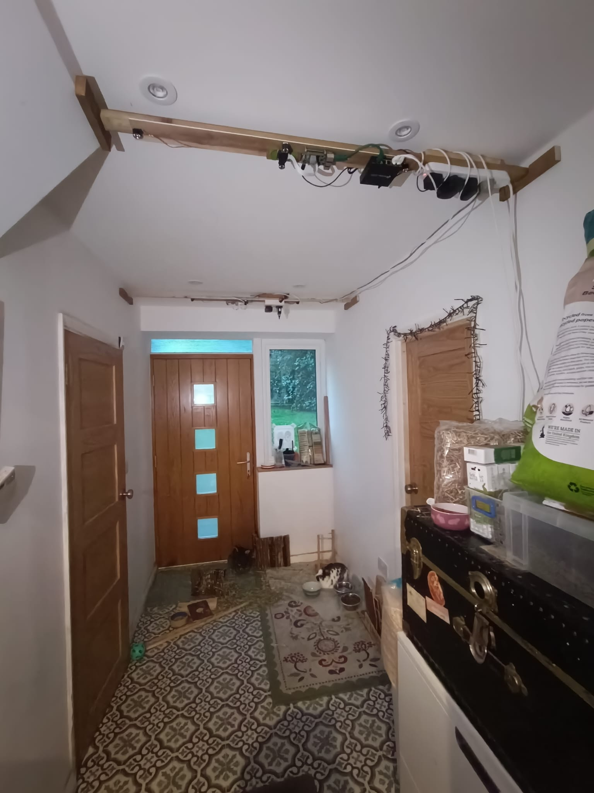

Full shot of room with 5MP Motorised IR-CUT OV5647 Camera for Raspberry Pi installed. See Appendix Analysis 4 for breakdown.

With these new cameras they swap filters to allow for night and proper day vision giving clearer images. They also had enough overlap to be able to be joined by the image stitching algorithm.

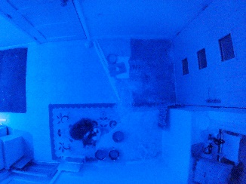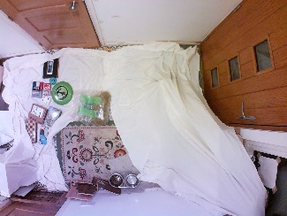

Day image of Raspberry Pi 5MP Motorised IR-CUT OV5647 Camera for Raspberry Pi

Night image of Raspberry Pi 5MP Motorised IR-CUT OV5647 Camera for Raspberry Pi

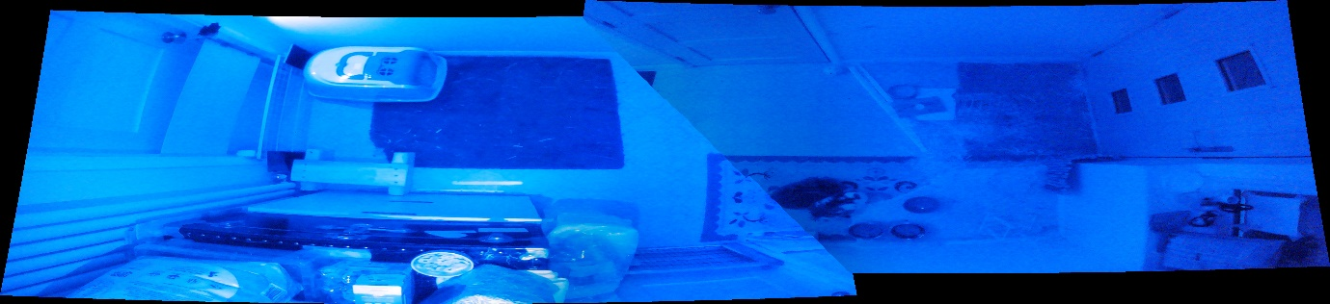

Full shot of room with 5MP Motorised IR-CUT OV5647 Camera for Raspberry Pi installed joined using algorithm without blending or cropping.

You can notice a visible seam across the image with a corner of the square carpet being mismatched. For a prototype this is enough to show at least that the system works. Later refinements will be made to allow for a more precise seem for the photo allowing a proper overlap

# Design

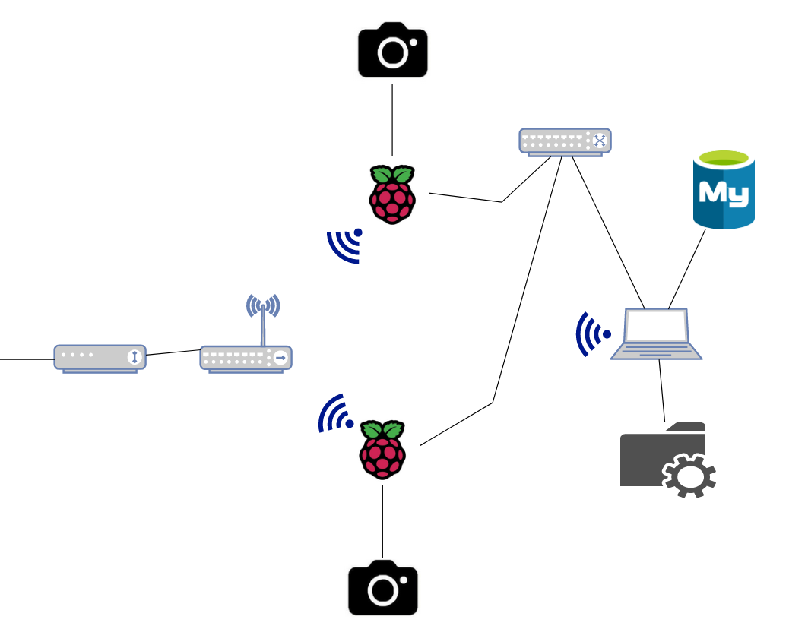

# Appendix

## Analysis

1. Q-Sean Scholand (me) A- Michael Scholand

Q) Hello, can you introduce yourself

A) Hi I am Michael Scholand

Q) What are your pets

A) I have two pets I have two rabbit who are sisters Cleo and Cinny

Q) Have you had any past pets

A) Yes, I’ve had loads

Q) Can you go through a few

A) Err yeah so, I had bunnies when I was a kid probably around 5 or 6 different rabbits over the years, A dog I had for 14 years. A hedgehog here, and obviously some goldfish. So, a variety of things but right now it’s just two bunnies.

Q) When did you get the rabbits

A) It was 2020 just around the start of lockdown

Q) How often do you see your two bunnies every day do you visit them hourly or?

A) So, the bunnies live in the house their free roaming in a room which is right outside my office/bedroom, so I pass through their room probably every 30 minutes or hour over the course of the day, so I easily see them over a dozen times per day. And sometimes I stop and stroke them other times I speak to them and walk through.

Q) How much time over a day do you spend with the rabbits

A) Maybe around 20-30minutes

Q) Do you often have trips where you have to delegate responsibility of the rabbits to someone else

A) I wouldn’t say often but I do more working from home now. But if I do go away obviously the pets don’t go with me so I have to ask my children to come or my neighbour if they are not available.

Q) Have there been times where you've returned from trips and a rabbit was acting weird if so, what did you do

A) Yeah, there was one time I came back from a trip and Cinny were acting strange, she wasn’t going for treats and her urine looked opaque and yellow and it was quite pungent. And so, I contacted my son the owner of the pet and we decided to go to the animal hospital in Potters Bar as it was quite late so our normal vets was closed. I think it was called Queen Elizabeth the second animal hospital to have her checked out because bunnies have delicate digestive systems and if they get messed up… I don’t know so we didn’t want to risk anything so let go and get her checked out by a vet.

Q) How much time did this take

A) Well in the A&E of an animal hospital serving the area of Hampshire there are other people with their pets there that night and only 1 or 2 vets on duty that night, so we waited around an hour before we got seen and then we were with them for about 20-30 minutes and then had to wait another 30 for the prescription and meds all in it took around 3 hours at the hospital and another hour transport. The good thing it we were able to get that level of care for our pets urgently, I don’t regret it.

Q) how much did this cost

A) 250-300 pounds yeah it was kind of expensive.

Q) Do you often take your rabbits to the vets

A) Yes at least once a year, they have an annual vaccination and occasionally if something comes up, we go to them interim.

Q) Do you have insurance if not how much does it cost you for each trip

A) Yeah, we don’t have pet insurance a few of my friends do and they have suggested that I get it but typically if it is a routine check up and vaccination it is 40-50 pounds per bunny so around £100 total. However, if it’s a bit more involved like surgery the last visit was actually for Cleo who had a parasite in the eye and that eye had to be removed costing over £600 it was quite a lot.

Q) Are you ever concerned about their health while you are away

A) To be honest I guess yes because I feel as though their health is bad and I am around I can do something about it whereas if I’m away then it is more difficult to intervene I kind of just hope they’re going to be okay and their young they just turned 3 so I expect we’ll start to see issues in 3-4 years. But in the meantime, they’re in the healthy phase of their life and their well looked after. But yes, it is something that concerns me as I want to know if their going to be okay.

Q) How large is the room you keep your rabbits in

A) Its about 2 metres by 4metres

Q) Would you be interested in a non-intrusive way of measuring their behaviour

A) Yes definitely

Q) How much would you be willing to spend on such a product

A) What would the product do would it just monitor their health

Q) It would provide you updates with how your rabbit is doing so you can tell that its average behaviour or if it is something you should check with your vets for. It would also provide a video covering their day which would be shown to you on a website.

A) Oh wow that’s really cool, no I would love that I think I would easily spend around £100-150 on that as it would give me peace of mind as I can check in on them whenever I needed.

Q) Thank you for your time.

1. Q-Sean Scholand A-Rachel Barnes(vet) (Removed chatting parts)

Q) Is it possible to determine if a rabbit is sick through reduced movement?

A) Definitely because rabbits are a prey species they act and have an innate behaviour whereby they think that if they show illness, they would think they would be picked off by a predator. So, because of that they would have the usual stance of being alert and active and bright and so if they are under the weather and showing the signs of being under the weather, they would be quite sick. So, in terms of reduced movement well certainly we know and there have been clinical studies that have shown that if rabbits are in pain, they are less active and less mobile. It is also important to think about the time of day that you are monitoring them as they are a diurnal species and are definitely more active in the morning or evening and so during that middle period of the day you might expect them to be more relaxed and sleeping more so I wouldn’t want to misinterpret that data. But I would certainly agree that a less active rabbit that is siting around would certainly have some sort of pain or discomfort somewhere. There are also more signs eg food they graze throughout the day so if they aren’t eating that’s another trait. There are also changes to how much their pooing, scratching their ears.

Q) Have you ever seen or heard of anything similar to what is described in this project idea?

A) Not specifically there are obviously lot of anecdotal evidence oh they’ve been a bit lethargic oh they’ve been lying around when their under the weather and there will be publication to show that rabbit that are less active may have a higher cortisol level but I don’t have one to hand. But I haven’t heard of something so specific in terms of using cameras.

A) What do you think would be some pros/cons of the product?

Q) First it’s a really great way to show how active a rabbit it and showing when they are active which is nice to be able to tell an owner it might be able to shed more data on diurnal behaviour during the times of day and it really great to show with a big enough sample size vs 5 who where shown to be normal that there is a significant difference. I suppose the cons is really that its hard for the cameras to detect specific behaviour like eating and things that we’ve discussed like breathing. But generally, I think it’s a really great idea.

Q) Do you think this product potentially be useful for home care of a sick rabbit

A) Well, I certainly think the use of cctv is really useful because unless you have a rabbit that is living in a house that the owner is really good at monitoring all the time. Its hard for the owners to know. But definitely knowing if a rabbit is feeling well, it would be bright and active moving around and so to have that data to show its not is a great way to see if there’s an improvement or not.

Q) Could this be useful for other types of animals?

Q) I would be quite interested in it’s use in geriatric cats simply because with people’s dogs particularly with arthritis their owners are particularly aware a dog is limping or undern the weather because when your taking it out every day for a walk they can visibly see that it’s limping. But it interesting as we’ve recently been talking about this with another practice as we are talking about the introduction of new arthritis drugs. Lots of people don’t associate inactive with their cats as a sign of discomfort they just think it’s a sign of an animal just getting old. So, it just sleeps all day. Whereas some of this is because the cats in pain or because it’s got a significant joint disease and doesn’t want to move around. So, I think that would be really interesting to see if you were to compare a number of geriatric cats who have arthritis that are on a medication vs not on a medication and see the difference. I bet there would be. In terms of other animals any kind of rodent would be interesting to monitor because they are so vast in when heir active and that would be interesting to see.

Q) Any other comments or suggestions based on your knowledge of bunnies?

A) I suppose you could consider where their being active on the run – eg in a multi-level run if their hopping around and jumping up floors are less likely to be in pain. Whereas if you have it on a very standard one level you might not be able to get that data. It would also be quite interesting to see how the rabbit react to humans seeing their prey reflexes.

1. Program of image stitching algorithm in prototype stages :

import cv2

import numpy as np

from matplotlib import pyplot as plt

from stitching.images import Images

from stitching.feature_detector import FeatureDetector

from stitching.feature_matcher import FeatureMatcher

from stitching.subsetter import Subsetter

from stitching.camera_estimator import CameraEstimator

from stitching.camera_adjuster import CameraAdjuster

from stitching.camera_wave_corrector import WaveCorrector

from stitching.warper import Warper

from stitching.cropper import Cropper

from stitching.seam_finder import SeamFinder

from stitching.exposure_error_compensator import ExposureErrorCompensator

from stitching.blender import Blender

#made using https://github.com/OpenStitching/stitching_tutorial/blob/master/docs/Stitching%20Tutorial.md

class stitch():

    def __init__(self):

        self.first_run=True

        self.images=[]

        self.low_imgs=[]

        self.medium_imgs=[]

        self.final_imgs=[]

        self.feastures=[]

        self.matches=[]

        self.camera=[]

    def stitch_and_save(self,image1path,image2path,name):

        self.prep_images(image1path,image2path)

        if self.first_run==True:

            self.find_and_match_features()

        self.subset()

        if self.first_run==True:

            self.camera_function()

        self.putting_together()

        self.save_img(name)

    def prep_images(self,image1path,image2path): #prepares images

        load_images=[image1path,image2path]

        self.images = Images.of(load_images)

        self.low_imgs = list(self.images.resize(Images.Resolution.LOW))

        self.medium_imgs = list(self.images.resize(Images.Resolution.MEDIUM))

        self.final_imgs = list(self.images.resize(Images.Resolution.FINAL))

    def find_and_match_features(self): #only run once to decrease time taken when image stitching

        finder = FeatureDetector(detector='orb',nfeatures=50000)#sift gives a good result aswell

        matcher = FeatureMatcher()#matcher_type='affine'

        self.features = [finder.detect_features(img) for img in self.medium_imgs]

        self.matches = matcher.match_features(self.features)

        print(matcher.get_confidence_matrix(self.matches))

        '''all_relevant_matches = matcher.draw_matches_matrix(self.medium_imgs, self.features, self.matches, conf_thresh=1, #for testing to see matches

                                                   inliers=True, matchColor=(0, 255, 0))

        keypoints_center_img = finder.draw_keypoints(self.medium_imgs[0], self.features[0])

        plot_image(keypoints_center_img, (15,10))

        keypoints_center_img = finder.draw_keypoints(self.medium_imgs[1], self.features[1])

        plot_image(keypoints_center_img, (15,10))

        for idx1, idx2, img in all_relevant_matches:

            print(f"Matches Image {idx1+1} to Image {idx2+1}")

            plot_image(img, (20,10))'''

    def subset(self): #might not be needed change

        if self.first_run==True:

            self.subsetter = Subsetter(confidence_threshold=1.0)

            self.indices = self.subsetter.get_indices_to_keep(self.features, self.matches)

        self.medium_imgs = self.subsetter.subset_list(self.medium_imgs, self.indices)

        self.low_imgs = self.subsetter.subset_list(self.low_imgs, self.indices)

        self.final_imgs = self.subsetter.subset_list(self.final_imgs, self.indices)

        self.features = self.subsetter.subset_list(self.features, self.indices)

        self.matches = self.subsetter.subset_matches(self.matches, self.indices)

        self.images.subset(self.indices)

    def camera_function(self): # constant

        camera_estimator = CameraEstimator()

        camera_adjuster = CameraAdjuster()

        wave_corrector = WaveCorrector()

        self.cameras = camera_estimator.estimate(self.features, self.matches)

        self.cameras = camera_adjuster.adjust(self.features, self.matches, self.cameras)

        self.cameras = wave_corrector.correct(self.cameras)

    def putting_together(self):

        if self.first_run==True:

            self.warper = Warper()

            self.warper.set_scale(self.cameras)

            low_sizes = self.images.get_scaled_img_sizes(Images.Resolution.LOW)

            camera_aspect = self.images.get_ratio(Images.Resolution.MEDIUM, Images.Resolution.LOW)  # since cameras were obtained on medium imgs

            #warping the smaller images

            warped_low_imgs = list(self.warper.warp_images(self.low_imgs, self.cameras, camera_aspect)) #why do we warp low img first check

            warped_low_masks = list(self.warper.create_and_warp_masks(low_sizes, self.cameras, camera_aspect))

            low_corners, low_sizes = self.warper.warp_rois(low_sizes, self.cameras, camera_aspect)

            #warping the final images

            self.camera_aspect = self.images.get_ratio(Images.Resolution.MEDIUM, Images.Resolution.FINAL) #all above constant

        final_sizes = self.images.get_scaled_img_sizes(Images.Resolution.FINAL)

        warped_final_imgs = list(self.warper.warp_images(self.final_imgs, self.cameras, self.camera_aspect))

        warped_final_masks = list(self.warper.create_and_warp_masks(final_sizes, self.cameras, self.camera_aspect))

        final_corners, final_sizes = self.warper.warp_rois(final_sizes, self.cameras, self.camera_aspect)

        if self.first_run==True:

            self.seam_finder = SeamFinder() #seam finding

            seam_masks = self.seam_finder.find(warped_low_imgs, low_corners, warped_low_masks) #above constant

            self.seam_masks = [self.seam_finder.resize(seam_mask, mask) for seam_mask, mask in zip(seam_masks, warped_final_masks)]

            self.compensator = ExposureErrorCompensator() #exposure error correcting

            self.compensator.feed(low_corners, warped_low_imgs, warped_low_masks) #above constant

        compensated_imgs = [self.compensator.apply(idx, corner, img, mask)  for idx, (img, mask, corner) in enumerate(zip(warped_final_imgs, warped_final_masks, final_corners))]

        #blending together

        if self.first_run==True:

            #self.blender = Blender()

            self.blender=Blender(blender_type='no', blend_strength=5) #Removes blending

        self.blender.prepare(final_corners, final_sizes)#above constant

        for img, mask, corner in zip(compensated_imgs, self.seam_masks, final_corners):

            self.blender.feed(img, mask, corner)

        self.panorama, _ = self.blender.blend()

    def save_img(self,name):

        #self.panorama=cv2.cvtColor(self.panorama, cv2.COLOR_BGR2RGB)

        cv2.imwrite(name, self.panorama)

        self.first_run=False

'''from matplotlib import pyplot as plt #for testing

import cv2 as cv

import numpy as np

def plot_image(img, figsize_in_inches=(5,5)):

    fig, ax = plt.subplots(figsize=figsize_in_inches)

    ax.imshow(cv.cvtColor(img, cv.COLOR_BGR2RGB))

    plt.show()

def plot_images(imgs, figsize_in_inches=(5,5)):

    fig, axs = plt.subplots(1, len(imgs), figsize=figsize_in_inches)

    for col, img in enumerate(imgs):

        axs[col].imshow(cv.cvtColor(img, cv.COLOR_BGR2RGB))

    plt.show()'''

if __name__=="__main__":

    import time

    def timer_start():

        global start_time

        start_time=time.time()

    def timer_stop():

        global start_time

        end_time=time.time()

        print(end_time-start_time)

    x=stitch()

    z=0

    while z==0:

        try: #Repeat over till confidence score is high enough to match images

            x.stitch_and_save("server/test8L.png","server/test8R.png","server/testingtestwithoutblend.png")

            z=1

        except:

            pass

    x.stitch_and_save("server/test9L.png","server/test9R.png","server/testing2testwithoutblend.png") #Based on previous matched image, match this one to same criteria

1. Close up images of prototype:

Power supply leading to other module.

Power supply for Networking switch.

1 of 2 independent IR lights automatically turns on depending on light levels.

Power supply for 2 independent IR lights.

Power supply For Raspberry Pi.

Networking switch for 2 Pis and server when upgraded.

Raspberry Pi for controlling picture taking.

Camera with automatic IR filter swapping alongside two automatic IR lights dependent on Pis power.

Method of attachment: wood beam across room is resting on a 2 by 8 with a notch cut in. This allows for easier removal for upgrades.

Raspberry pi for controlling picture taking.

Camera with automatic IR filter swapping alongside two automatic IR lights dependent on Pis power.

Power supply for 2 independent IR lights.

Power supply For Raspberry pi

Ethernet + power supply leading to other Pi.

1. <https://todaysveterinarybusiness.com/pets-appa-survey-covid/> [Accessed 28 08 2023]
2. <https://www.bbc.com/worklife/article/20230206-the-companies-backtracking-on-flexible-work> [Accessed 28 08 2023]
3. <https://www.theguardian.com/lifeandstyle/2022/feb/13/we-are-exhausted-and-burntout-vets-in-crisis> [Accessed 21 09 2023]
4. <https://www.fortunebusinessinsights.com/pet-care-market-104749> [Accessed 23 09 2023]
5. <https://www.fortunebusinessinsights.com/pet-care-market-104749> [Accessed 23 09 2023]
6. <https://www.moneysupermarket.com/pet-insurance/does-pet-insurance-cover-vet-visits/#_what_vet_bills_are_not_covered_by_pet_insurance_> [Accessed 20 09 2023]
7. See Appendix Analysis 1 for full interview.
8. See Appendix Analysis 2 for full interview.
9. <https://www.nc3rs.org.uk/sites/default/files/2022-01/NC3Rs%20Rabbit%20Grimace%20Scale%20Poster%20%28EN%29.pdf> [Accessed 23 09 2023]
10. <https://www.vettimes.co.uk/are-rabbits-really-exotic/> [Accessed 23 09 2023]
11. <https://news.sky.com/story/people-three-times-more-likely-to-insure-pets-than-their-own-health-survey-finds-12288302> [Accessed 23 09 2023]
12. <https://www.confused.com/pet-insurance/guides/vet-treatment-prices> [Accessed 23 09 2023]
13. <https://tractive.com/en/pd/gps-tracker-cat?edition=cat-mini> [Accessed 23 09 2023]
14. <https://www.youtube.com/watch?v=Deyi0H7zpbY> [Accessed 23 09 2023]
15. <https://maven.pet/starter-bundle/> [Accessed 23 09 2023]
16. <https://www.nytimes.com/wirecutter/reviews/best-gps-pet-trackers/> [Accessed 23 09 2023]
17. <https://www.fitbark.com/en-GB/store/fitbark2> [Accessed 24 09 2023]
18. <https://thepihut.com/products/raspberry-pi-night-vision-camera> [Accessed 21 09 2023]
19. See Appendix Analysis 3
20. <https://thepihut.com/products/5mp-motorised-ir-cut-ov5647-camera-for-raspberry-pi> [Accessed 21 09 2023]